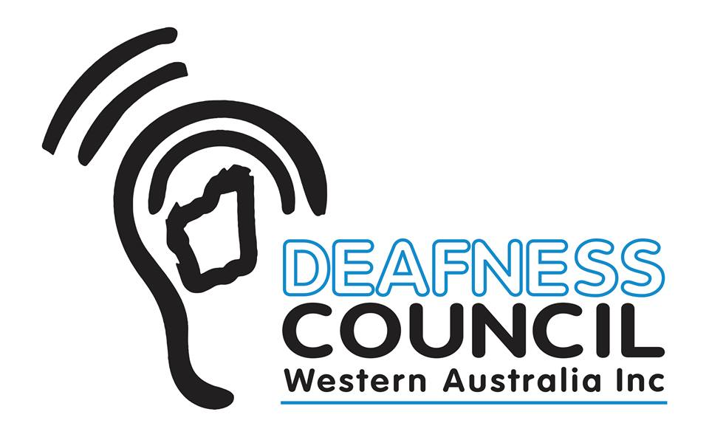
www.deafnesscouncilwa.org.au

Deafness Council WA
Quadrant Energy
Scholarship
2017

APPLICATION FORM

NAME OF INDIVIDUAL OR ORGANISATION:

ADDRESS:

DATE OF BIRTH:

DATE ORGANISATION ESTABLISHED;

CONTACT DETAILS:
Ph:
Mob:
Email:

HEARING LOSS OF INDIVIDUAL OR ORGANISATIONS MEMBERS:
(When and how acquired)
(Loss in one or both ears?)

ORGANISATION CHARTER/CONSTITUTION:
METHOD OF COMMUNICATION:
(Auslan /Oral)

PROGRAM PROPOSED:

COSTS OF PROGRAM:

USE OF SCHOLARSHIP FUNDS:

HOW THIS WILL ASSIST IN DEVELOPING INDIVIDUAL/ORGANISATION SKILLS:

All submissions must be received by 5pm on October 31st, 2017. These can be sent by email to yrrab@iinet.net.au or posted to PO Box 1388, South Perth WA 6951.

